Mert 18/12/2020

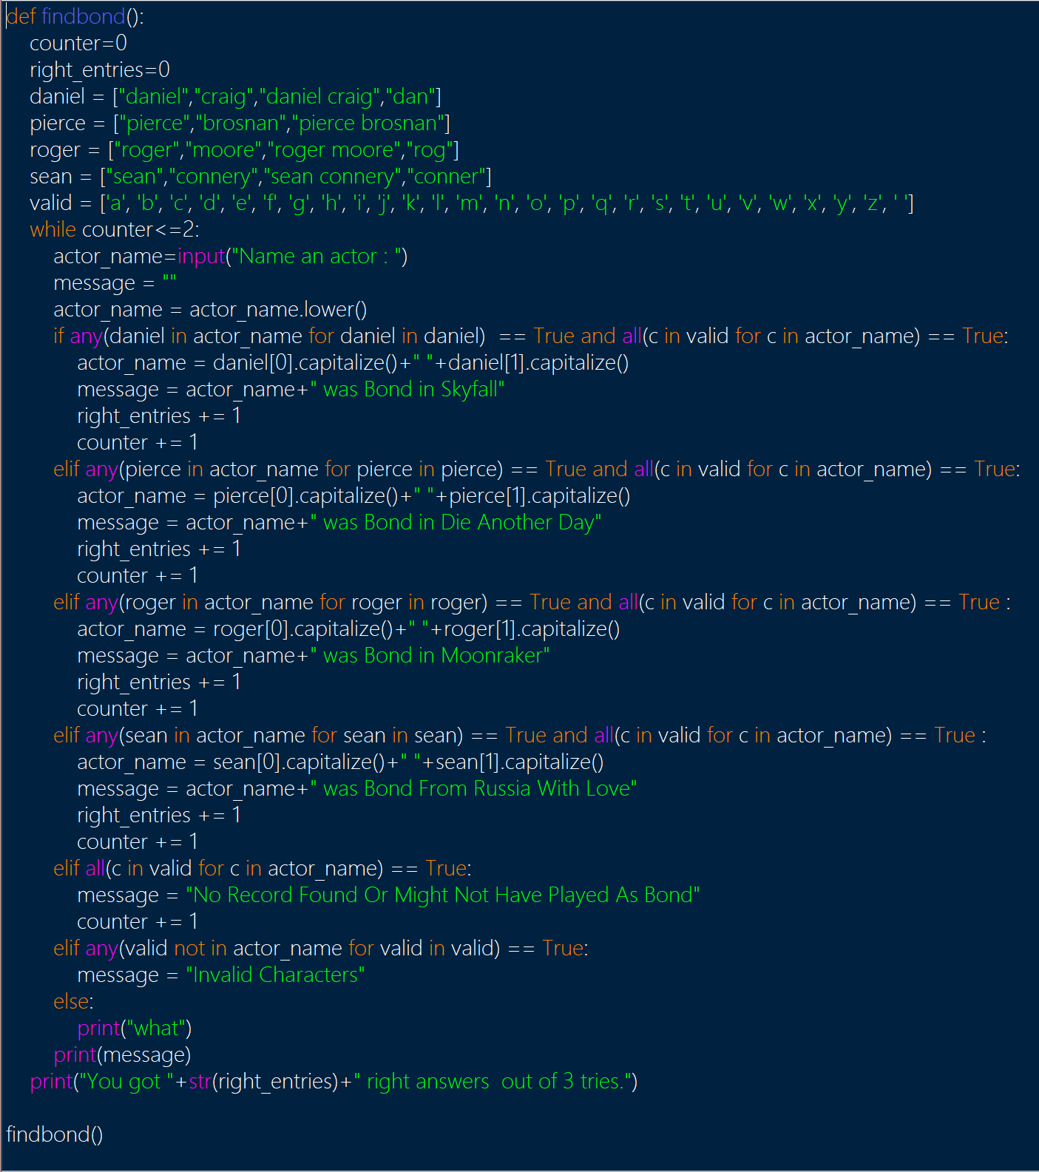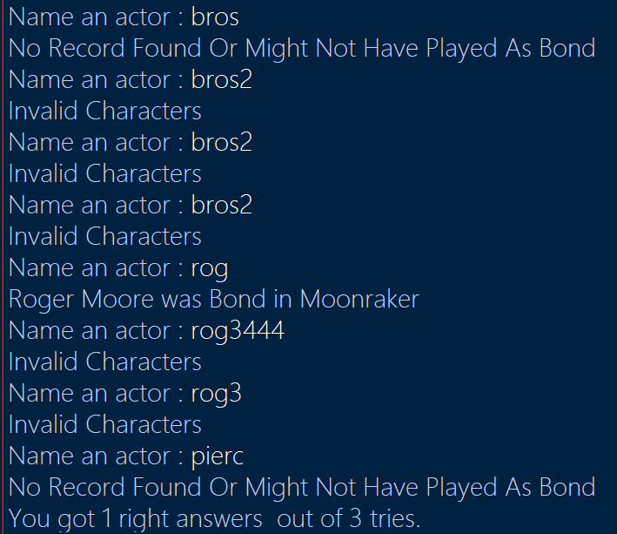

code:

def findbond():#starts function

counter=0#resets counter

right_entries=0#resets right entires

daniel = ["daniel","craig","daniel craig","dan"]#these define right names

pierce = ["pierce","brosnan","pierce brosnan"]

roger = ["roger","moore","roger moore","rog"]

sean = ["sean","connery","sean connery","conner"]

valid = ['a', 'b', 'c', 'd', 'e', 'f', 'g', 'h', 'i', 'j', 'k', 'l', 'm', 'n', 'o', 'p', 'q', 'r', 's', 't', 'u', 'v', 'w', 'x', 'y', 'z', ' ']#defines valid characters

while counter<=2:#asks for input while counter is not 4 or above

actor_name=input("Name an actor : ")

message = ""

actor_name = actor_name.lower()

if any(daniel in actor_name for daniel in daniel) == True and all(c in valid for c in actor_name) == True:#all these check if the input has one of the names from the lists and they do not contain invalid characters, if so they add to the right entries

actor_name = daniel[0].capitalize()+" "+daniel[1].capitalize()

message = actor_name+" was Bond in Skyfall"#defines message

right_entries += 1#adds to right entries

counter += 1#adds to counter to eventually end loop

elif any(pierce in actor_name for pierce in pierce) == True and all(c in valid for c in actor_name) == True:

actor_name = pierce[0].capitalize()+" "+pierce[1].capitalize()

message = actor_name+" was Bond in Die Another Day"

right_entries += 1

counter += 1

elif any(roger in actor_name for roger in roger) == True and all(c in valid for c in actor_name) == True :

actor_name = roger[0].capitalize()+" "+roger[1].capitalize()

message = actor_name+" was Bond in Moonraker"

right_entries += 1

counter += 1

elif any(sean in actor_name for sean in sean) == True and all(c in valid for c in actor_name) == True :

actor_name = sean[0].capitalize()+" "+sean[1].capitalize()

message = actor_name+" was Bond From Russia With Love"

right_entries += 1

counter += 1

elif all(c in valid for c in actor_name) == True:#checks if valid characters are in there

message = "No Record Found Or Might Not Have Played As Bond"

counter += 1

elif any(valid not in actor_name for valid in valid) == True:#checks if characters are invalid if all other checks fail

message = "Invalid Characters"

else:#this is just in case some weird thing happens

print("what")

print(message)#prints score